**8. Test User Management Microservice with MySQL Database in Kubernetes**

--- **note** – in this lecture, we are going to learn user management service deployment and nodeport service.

**Create UserManagement Service Deployment & Service**

--- **note** – whatever I created previously, I deleted them all so now I will recreate them all at once.

--- **Kubectl get all** – to list everything.



**# Create Deployment & NodePort Service**

--- **kubectl apply -f kube-manifests/** -

**# List Pods**

--- **kubectl get pods** -

**# Verify logs of Usermgmt Microservice pod**

--- **kubectl logs -f <Pod-Name>** -

**# Verify sc, pvc, pv**

--- **kubectl get sc,pvc,pv** – to list these at once.

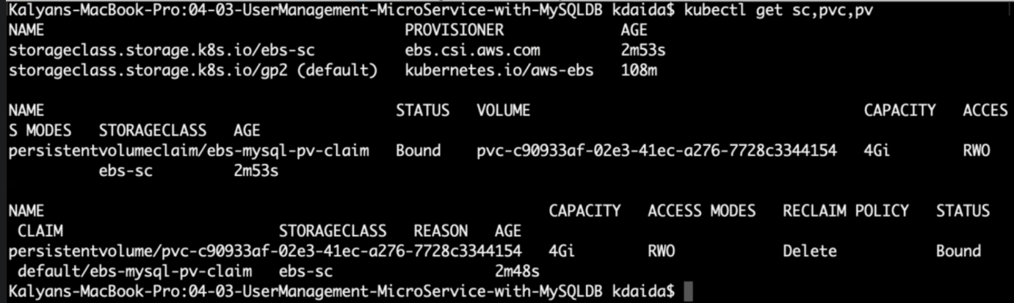

--- **Problem Observation:** If we deploy all manifests at a time, by the time mysql is ready our User Management Microservice pod will be restarting multiple times due to unavailability of Database.

To avoid such situations, we can apply initContainers concept to our User management Microservice Deployment manifest.

We will see that in our next section but for now let’s continue to test the application

Access Application

--- **note** – out application should not start before the mysql container.

**# List Services**

--- **kubectl get svc** -

**# Get Public IP**

--- **kubectl get nodes -o wide**

**# Access Health Status API for User Management Service**

--- **http://<EKS-WorkerNode-Public-IP>:31231/usermgmt/health-status**